Introduction to Purpose System (Courier Management System)

Activity Diagram for Courier Management System

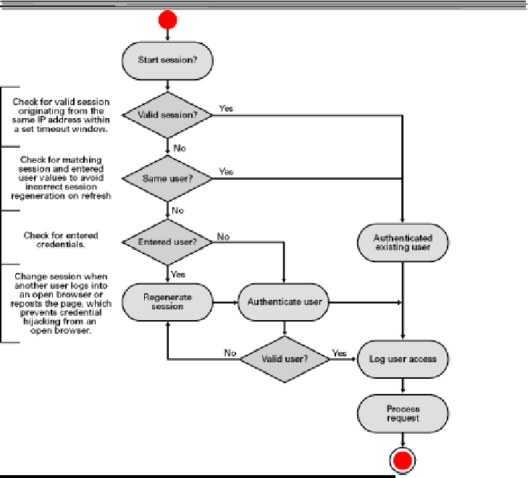

Component Diagram for Courier Management System

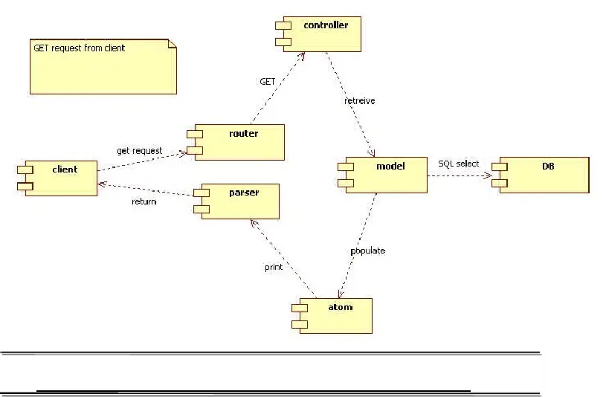

Dataflow Diagram for Courier Management System

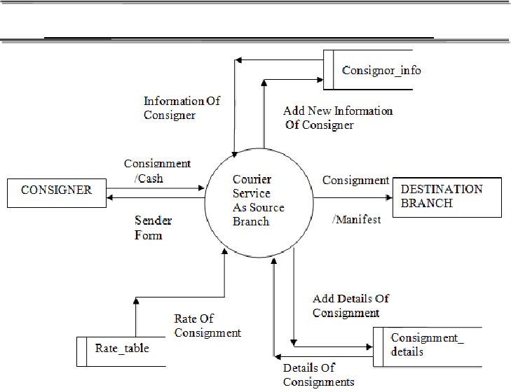

Class Diagram for Courier Management System

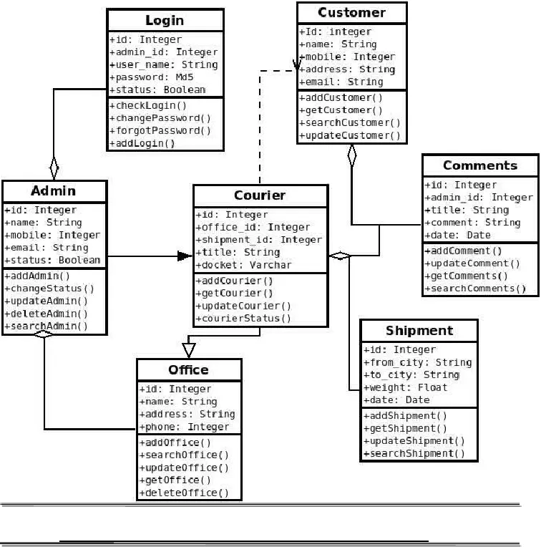

Deployment Diagram for Courier Management System

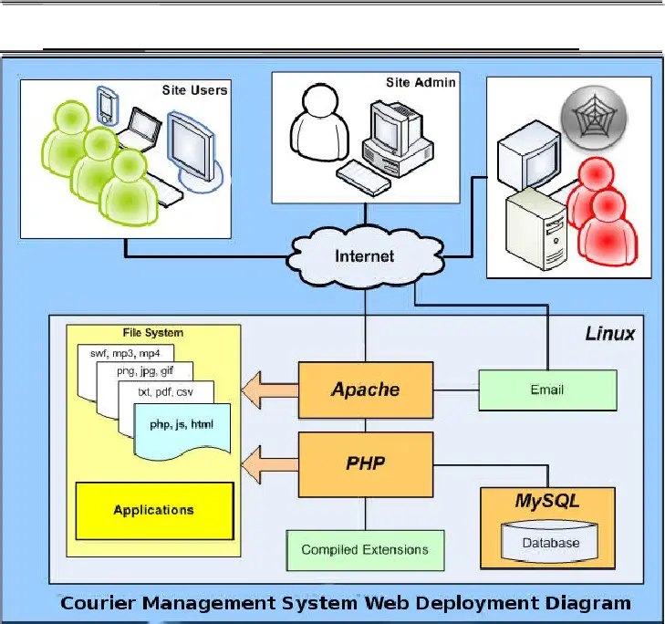

Entity Relationship Diagram for Courier Management System

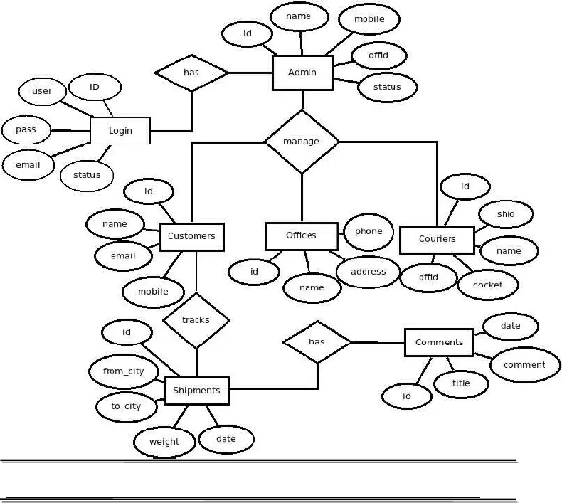

RDBMS Architecture Diagram

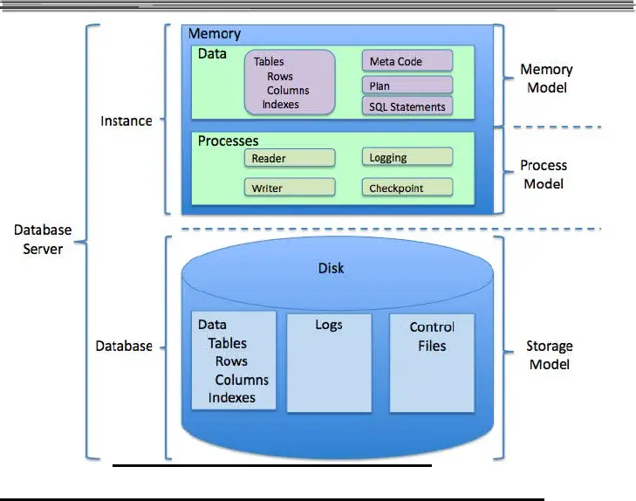

MVC (Model View Controller Flow) Diagram

